STUDENT NAME : DIVYA PRABHAKAR

STUDENT ID : 20240563

DUE DATE : 29 JULY, 2024 (MONDAY)

What is your favourite food recipe?

Choose your favourite food recipe, then draw a flowchart to visually represent the sequence of activities to complete the recipe and write a pseudocode of the same recipe.

Try to consider all design possibilities when drawing a flowchart or writing a pseudocode.

For instance, when you are considering variations to the recipe, these are the design possibilities.

* I HAVE SELECTED THE RECIPE TO PREPARE FRITTER BALLS ,THE FLOW CHART AND PSEUDOCODE IS ILLUSTRATED FURTHER.

PSEUDOCODE FOR THE RECIPE TO PREPARE FRITTER BALLS.

START

INPUT water, chickpea flour, cheese, salt

mix the ingredients

INPUT oil ,pan

manually, turn the paste into balls and fry

if flame = middium? then:

golden coloured fritter balls //OUTPUT

serve hot

else:

Undercooked fritter balls //OUTPUT

RETURN manually, turn the paste into balls and fry

END

FLOWCHART FOR THE RECIPE TO PREPARE FRITTER BALLS.

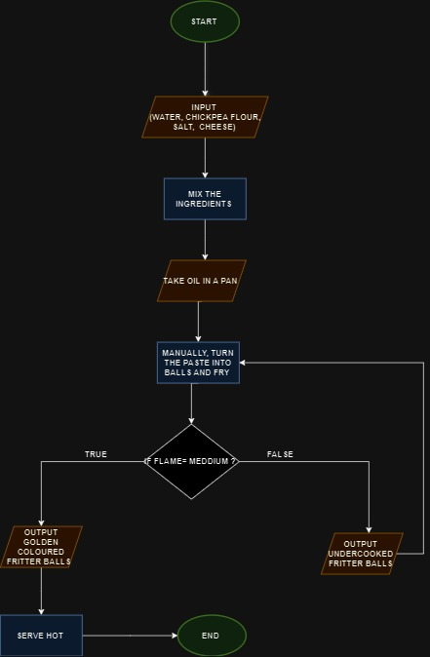

DIFFERENT COLOURS OF THE FLOW CHART INDICATES DIFFERENT FUNCTIONS

* GREEN : START/ END
* RED : INPUTS AND OUTPUTS
* BLUE : PROCESS
* BLACK : CONDITIONS